


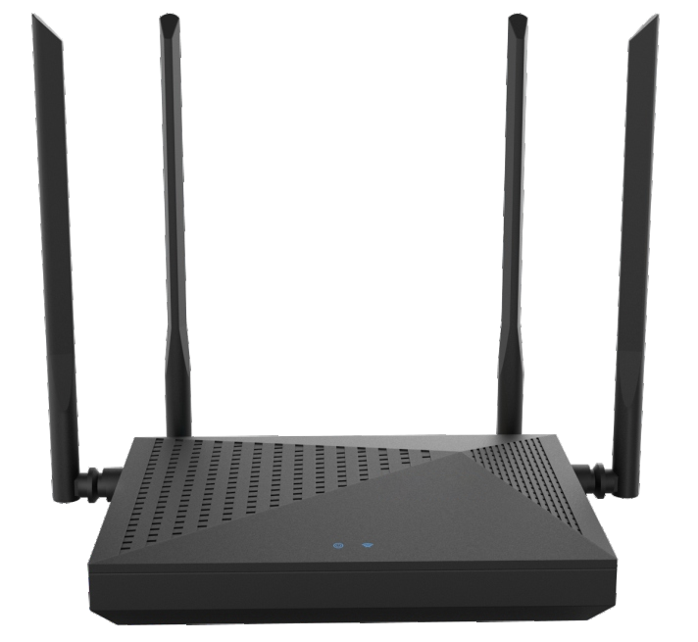

SWR-1200L4
2100M Gigabit WIFI Router

SWR-1200L4 is a 1200M 11AC dual-band wireless router specially designed for large-sized apartments with over 100Mbps FTTH network.The router is equipped with dual-core CPU and DDR3 memory,it enables the system to run fast and stably.
With 128MB large memory,it has a larger data cache space to guarantee game acceleration and more functions. The built-in independent PA / LNA signal enhancement module and external 4 high-gain omnidirectional antennas produce strong signal penetration performance,which truly help to achieve the full coverage of dual-band WIFI in villas and large-sized apartments. SWR-1200L4 is widely used in various applications such as wireless relay, LED light / WIFI timer switch, USB sharing etc. It is an ideal


2.4G 5G
Dual-band Dual-core CPU


Full Gigabit Ports

router for requirement of large coverage, signal penetration and smooth surﬁng.
4xOmnidirectional Antennas
MU-MIMO
Dual wireless CPU
Ipv6

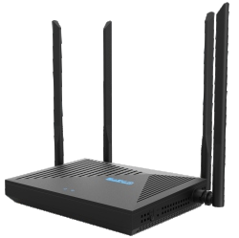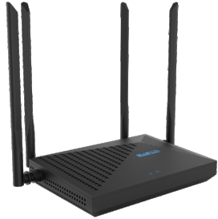

Specification

IEEE 802.11b/g/n 2.4GHz
WPS/Reset
CE, RoHS

Button
160×110×30mm
W x D x H

Certiﬁcation
External Power Supply 12VDC/1A
1×10/100/1000Mbps
Interface WAN Port
4×10/100/1000Mbps
Interface LAN Ports
128MB/8MB
Memory/Storage
MT7621D+MT7603E
+MT7613B
Chipset
2×2.4GHz

Antenna
Wireless Modes
2.4-2.5GHz;5.15-5.25GHz
Frequency
300Mbps(2.4GHz)

Wireless Speeds

Wireless Standards
IEEE 802.11ac/n/a 5GHz

867Mbps(5GHz)

Wireless Router; WISP; AP

2×5GHz

Product Interface
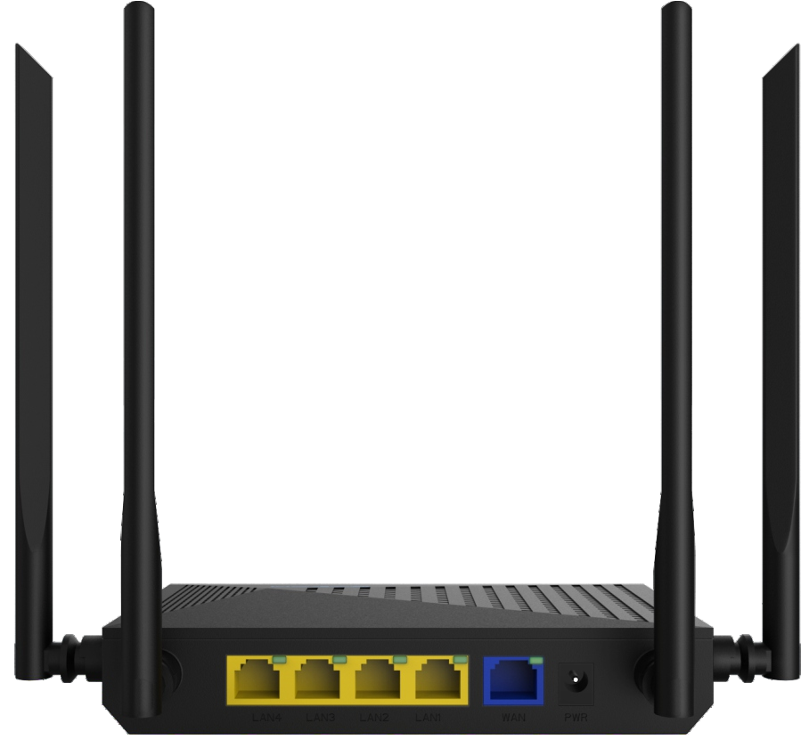
PWR
LAN WAN

